Section 1: Error-Driven Learning in Java

Snippet 1:
public class Main {
public void main(String[] args) {
System.out.println("Hello, World!");
}
}

Error:-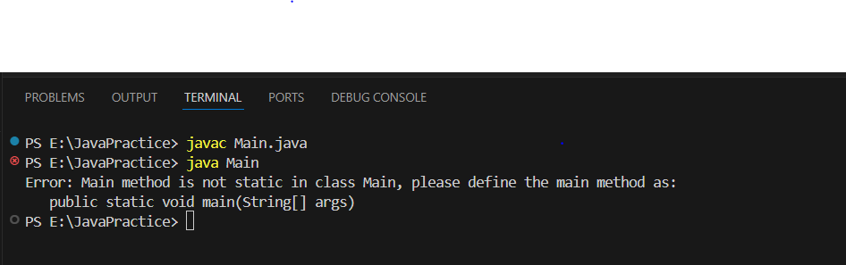

Corrected Code:

public class Main {
public static void main(String[] args){
System.out.println("Hello, World!");
}
}

Output:

Hello, World!

Reason:Main method is not static in class Main, main method as:
public static void main(String[] args)

Snippet 2:
public class Main
{
static void main(String[] args) {
System.out.println("Hello, World!");
}
}

Error:-
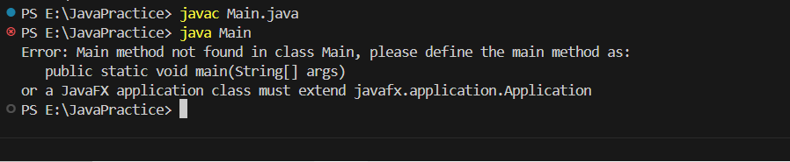

Corrected Answer:-

public class Main {
public static void main(String[] args) {
System.out.println("Hello, World!");
}
}

Reason :-
Main method not found in class Main, please define the main method as:
public static void main(String[] args)

Snippet 3:

public class Main {
public static int main(String[] args) {
System.out.println("Hello, World!");
return 0;
}

Error:
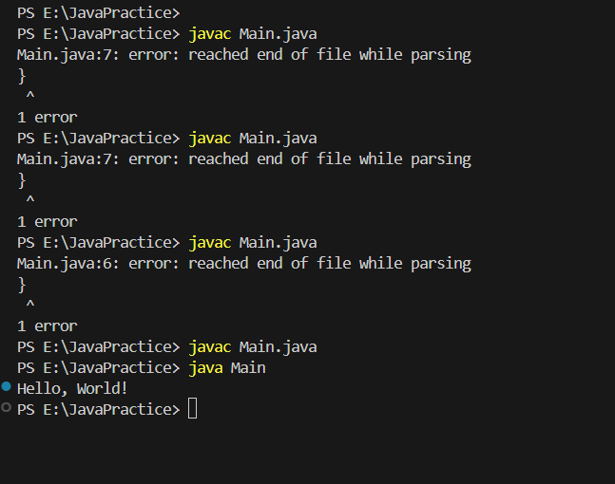

Corrected Answer:

public class Main {
public static void main(String args[]) {
System.out.println("Hello, World!");
}
}
Reason:-

Snippet 4:
public class Main {
public static void main() {
System.out.println("Hello, World!");
}
}
Error:-

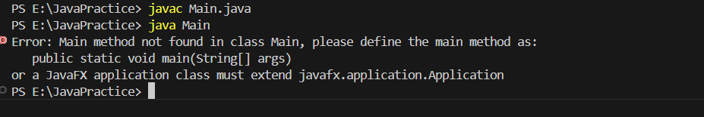

Corrected Answer:-
public class Main {
public static void main(String args[]) {
System.out.println("Hello, World!");
}
}

Reason:-
The Main method is missing as String args[]

Snippet 5:
public class Main {
public static void main(String[] args) {
System.out.println("Main method with String[] args");
}
public static void main(int[] args) {
System.out.println("Overloaded main method with int[] args");
}
}

Snippet 6:

public class Main {
public static void main(String[] args) {
int x = y + 10;
System.out.println(x);
}
}

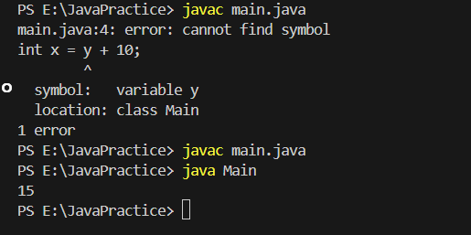

Corrected ans:-

public class Main {
public static void main(String[] args) {
int y = 5;
int x = y + 10;
System.out.println(x);
}
}

Reasoning:
Y is not initialise

Snippet 7:

public class Main {
public static void main(String[] args) {
int x = "Hello";
System.out.println(x);
}
}

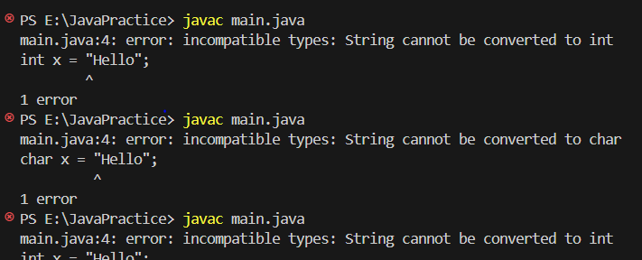

public class Main {
public static void main(String[] args) {
String x = "Hello";
System.out.println(x);
}
}

Reason:
Int cannot be converted to string

Snippet 8:
public class Main {
public static void main(String[] args) {
System.out.println("Hello, World!"
}
}

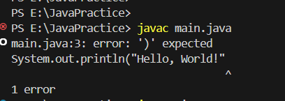

public class Main {
public static void main(String[] args) {
System.out.println("Hello, World!");
}
}

Reason
Print method expected bracket

Snippet 9:
public class Main {
public static void main(String[] args) {
int class = 10;
System.out.println(class);
}
}
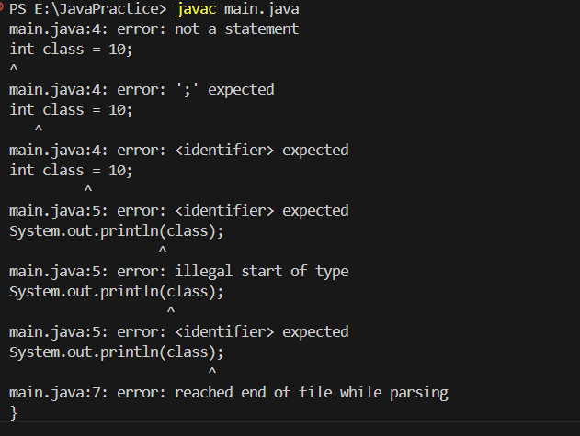

Snippet 10:
public class Main {
public void display() {
System.out.println("No parameters");
}
public void display(int num) {
System.out.println("With parameter: " + num);
}
public static void main(String[] args) {
display();
display(5);
}
}

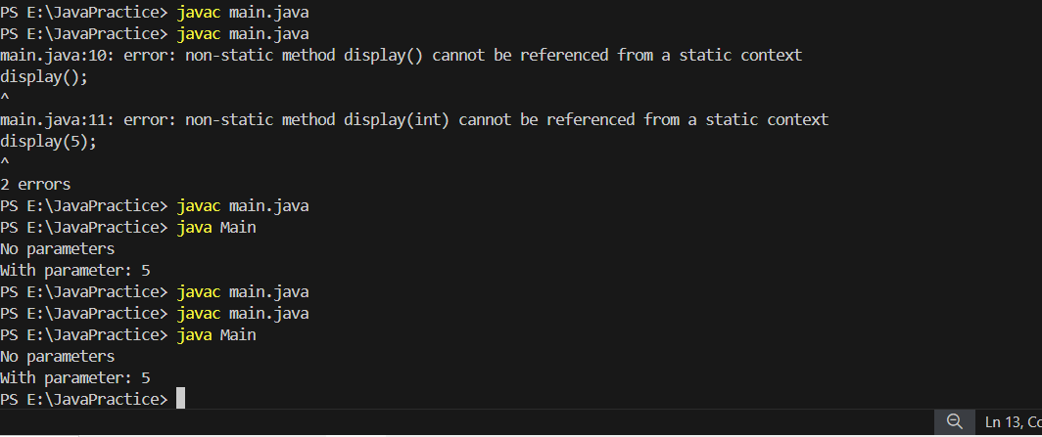

public class Main {
public static void display() {
System.out.println("No parameters");
}
public static void display(int num) {
System.out.println("With parameter: " + num);
}
public static void main(String[] args) {
display();
display(5);
}
}

Snippet 11:
public class Main {
public static void main(String[] args) {
int[] arr = {1, 2, 3};
System.out.println(arr[5]);
}
}

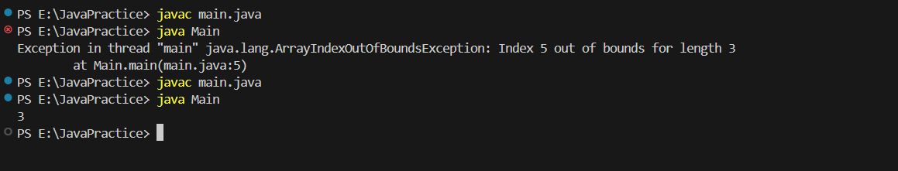

public class Main {
public static void main(String[] args) {
int[] arr = {1, 2, 3};
System.out.println(arr[2]);
}
}

Reason:-we providing value 5 thats why its going array out of bonds

Snippet 12:

public class Main {
public static void main(String[] args) {
while (true) {
System.out.println("Infinite Loop");
}
}
}

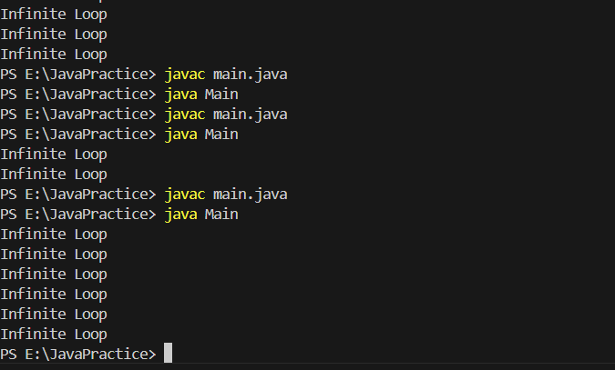
public class Main {
public static void main(String[] args) {
while (true) {
System.out.println("Infinite Loop");
}
}
}

public class Main {
public static void main(String[] args) {
int a=10;

while (a>=5 ) {
System.out.println("Infinite Loop");
a--;
}

}
}

Snippet 13:

public class Main {
public static void main(String[] args) {
String str = null;
System.out.println(str.length());
}
}

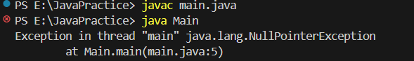

public class Main {
public static void main(String[] args) {
String str = "Mohini";
System.out.println(str.length());
}
}

Snippet 14:
public class Main {
public static void main(String[] args) {
double num = "Hello";
System.out.println(num);
}
}

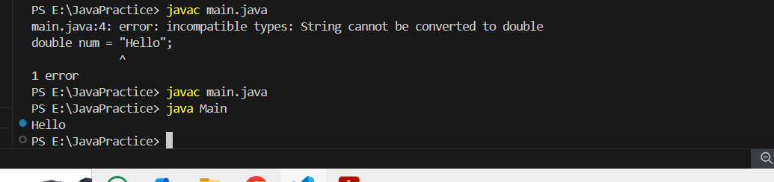

public class Main {
public static void main(String[] args) {
String num = "Hello";
System.out.println(num);
}
}

String cannot be converted to double

Snippet:

public class Main {
public static void main(String[] args) {
int num1 = 10;
double num2 = 5.5;
int result = num1 + num2;
System.out.println(result);
}
}

Error

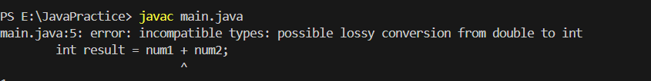

Corrected Code

public class Main {
public static void main(String[] args) {
int num1 = 10;
double num2 = 5.5;
double result = num1 + num2;
System.out.println(result);
}
}

Reason

Java does not allow implicit type conversion double to int

Snippet 17:
public class Main {
public static void main(String[] args) {
int a = 10;
int b = 5;
int result = a ** b;
System.out.println(result);
}
}

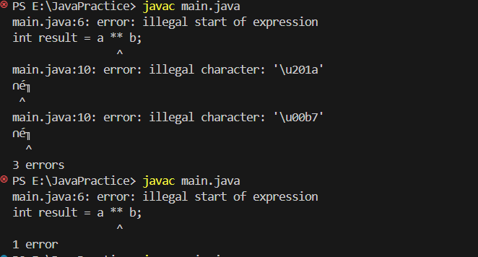

public class Main {
public static void main(String[] args) {
int a = 10;
int b = 5;
int result = a * b;
System.out.println(result);
}
}

illegal start of expression
int result = a ** b;
Snippet 18:
public class Main {
public static void main(String[] args) {
int a = 10;
int b = 5;
int result = a + b * 2;
System.out.println(result);
}
}

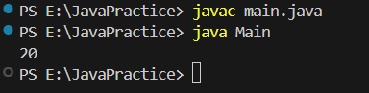

public class Main {
public static void main(String[] args) {
int a = 10;
int b = 5;
int result = a + b * 2;
System.out.println(result);
}
}

a=10;
b=5
10+(5*2)
First will solved bracket

Snippet 19:

public class Main {
public static void main(String[] args) {
int a = 10;
int b = 0;
int result = a / b;
System.out.println(result);
}
}

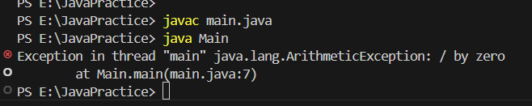

public class Main {
public static void main(String[] args) {
int a = 10;
int b = 0;

if (b != 0) {
int result = a / b;
System.out.println(result);
} else {
System.out.println("Error: Division by zero is not allowed.");
}
}
}

Snippet 20:
public class Main {
public static void main(String[] args) {
System.out.println("Hello, World")
}
}
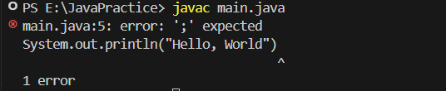

public class Main {
public static void main(String[] args) {
System.out.println("Hello, World");
}
}

Snippet 21:

public class Main {
public static void main(String[] args) {
System.out.println("Hello, World!");
// Missing closing brace here
}

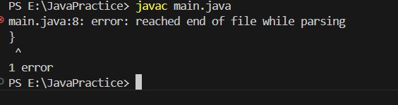

public class Main {
public static void main(String[] args) {
System.out.println("Hello, World!");
}
}

Snippet 22:
public class Main {
public static void main(String[] args) {
static void displayMessage() {
System.out.println("Message");
}
}
}

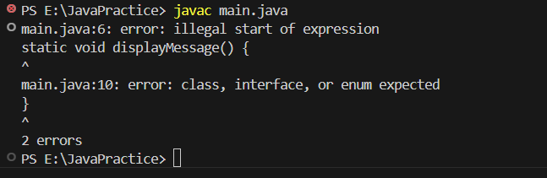

public class Main {
public static void main(String[] args)
{
}
static void displayMessage() {
System.out.println("Message");
}
}

Snippet 23:

public class Confusion {
public static void main(String[] args) {
int value = 2;
switch(value) {
case 1:
System.out.println("Value is 1");
case 2:
System.out.println("Value is 2");
case 3:
System.out.println("Value is 3");
default:
System.out.println("Default case");
}
}
}

Snippet 24:

public class MissingBreakCase {
public static void main(String[] args) {
int level = 1;
switch(level) {
case 1:
System.out.println("Level 1");
case 2:
System.out.println("Level 2");
case 3:
System.out.println("Level 3");
default:
System.out.println("Unknown level");
}
}
}

